SOLENT UNIVERSITY
School of Science and Engineering

MSc Computer Engineering

Academic Year 2024-2025

Student number (Q) 102592142

AE3 Report

Assignment 1

Networking – COM712

Contents
Research question 1: 3
Introduction: 3
Security: 3
Scalability: 5
Conclusion: 5
Research question 2: 6
Cloud computing: 6
Literature review: 9
Part 2 IPv6 Addressing of the Computer Network: 12
References: 15
Appendix: 20
Appendix 1 ipsec 20
Appendix 2 NAT. 20
Appendix 3 Virtualization. 21
Appendix 4 Cloud services 22
Appendix 5 Cloud models 22
Appendix 5 Venuestream network image 23

Table of Figures:
Figure 1 IPv6 vs IPv4 header. (NetworkAcademy, 2024) 4
Figure 2 different cloud deployment methods (Net Solutions, 2023) 6
Figure 3 Cloud SaaS, PaaS and IaaS diagram (Kinsta®, 2022) 7
Figure 4 Venuestream network 23

Table of Tables:
Table 1Table showing basic search terms 7
Table 2 Referencing scoring system including examples 9
Table 3 IPv6 subnet address 10
Table 4 IPv6 interface address table 11
Table 5 IPv6 interface address table 12

Research question 1:

Introduction:
This report is produced to identify why Venuestream would adopt IPv6 integration over IPv4. Both Security and Scalability will be taken into consideration given Venuestreams plans for expansion as well as their management of high security data. The report will produce reasons to which IPv6 will be beneficial and why it is a suitable option for the company.

Security:
As Venuestream deals with high security data, it would be necessary for the network to upgrade to IPv6 due to IPv6’ security protocols. Unlike IPv4, IPv6 integrates internet protocol security (IPsec) into its extension header structure as standard (Madsen, 2024).
See appendix 1 for the different protections IPsec provides.
Similar to this, IPv6 also has a significantly increased address space when compared to IPv4. This will assist in the resistance to certain attacks including IP address scanning and IP address exhaustion (Varonis, 2024). The increased address space allows for better address management and policies associated with allocation. This will consequently reduce the likelihood of addressing conflicts and as a result facilitate a more secure network (Madsen, 2024). This will aid greatly to Venuestream given their plans for expansion given that the security risks will not increase because of the implementation of more addresses.
Another improvement when compared to IPv4, includes the simplification of network address translation (NAT). Through IPv6 the need for network address translation is reduced significantly. NAT was commonly used in IPv4 networks as a layer of security, however due to its complexity it also presented vulnerabilities as it creates a bottleneck effect whereby all the traffic must pass through the NAT device (Larus, 2022). IPv6 provides end to end connectivity as a default which reduces the reliance on NAT and improves the overall network security (R. Ghafouri, A. Ashrafi and B. V. Vahda. T, 2015). This is especially significant given the nature of the network set-up by Venuestream and the volume of data passing through. The use of IPv6 will allow for a better standard of transfer without creating potential security risks through overload.
Finally, IPv6 exclusively utilises stateless auto-configuration. Dynamic host configuration protocol for IPv6 (DHCPv6) is used in the allocation process. This includes several security features to ensure that the address assignment and configuration is secure for IPv6 (Giac, 2022). An example feature includes Secure DHCPv6, which is an extension that provides security enhancements including a mechanism for authentication and integrity protection. By implementing transport layer security (TLS) ensures that data is only exchanged with trusted sources (B. Garn, D. E. Simos, F. Duan, Y. Lei, J. Bozic and F. Wotawa, 2019). This is significant for Venuestream as it will prevent hijacking of the network especially when transferring high security data.
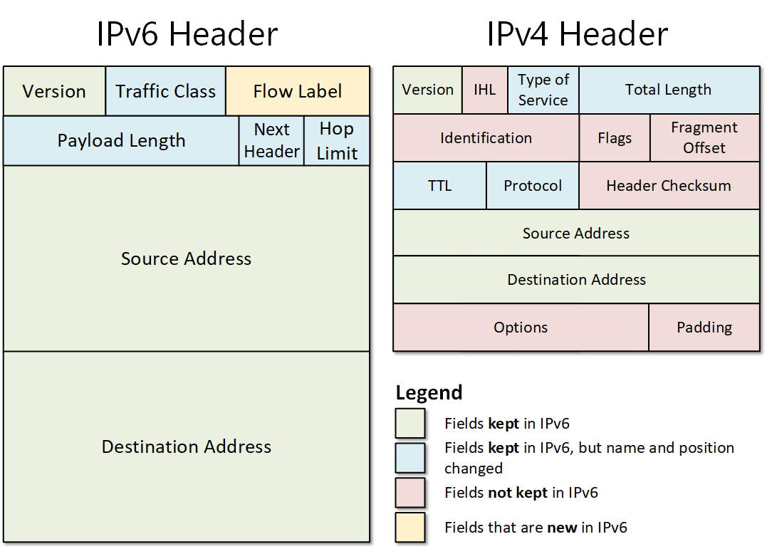
Figure 1 IPv6 vs IPv4 header. (NetworkAcademy, 2024)

Scalability:
Another benefit of transitioning from IPv4 to IPv6 includes the scalability of the protocol. Given the fact that the number of branches will increase 1000 times in the next 5 years it is important to have adequate address space to deal with the expansions. IPv6 (128 bit) has significantly larger address space than IPv4 (32 bits) and with that unique IP addresses can be allocated seamlessly (Amazon Web Services, Inc., 2024).
Please see appendix 2 for information on IPv4 and NAT and why this is not as scalable as IPv6.
Similar to this, IPv6 also helps reduce the time spent on monitoring and maintaining the systems, the IPv6 systems can conduct ‘stateless’ automatic configurations, to which it creates a unique IP address through the combination of LAN MAC addresses this is joined with a prefix provided by the network router (No DHCP needed) (H. Rafiee and C. Meinel, 2013). This is significant as given the potential expansion of the branches in the next 5 years, it is important that staffing costs are kept lower as well as the fact that the larger systems can manage themselves without requiring constant interference.
Finally, when discussing the potential adoption of IPv6, it is important to look towards the future. When improving and expanding the network, the adoption of IPv6 over IPv4 will be beneficial given the long-term potential of IPv6. By incorporating IPv6 the consumer is future-proofing and preparing for the large-scale integration and making sure that the system is already compatible with the applications of the future. As the number of applications and software using IPv6 increases, it is important to prepare for this change rather than the consumer having to completely update and renew the hardware that is currently being used (Kuerbis and Mueller, 2020).
Please see appendix 3 for information on virtualisation and software defined networks.

Conclusion:
It is recommended that Venuestream adopts IPv6 due to the security and scalability improvements that it can provide. The increase address space and applied autoconfiguration are clear strengths for future proofing the company and thus, moving away from IPv4 would benefit the company’s prospects for growth.

Research question 2:
What are the most appropriate cloud resources for an application which stores both the high security classified data for the CCTV and the low security classified environmental data?

Cloud computing:
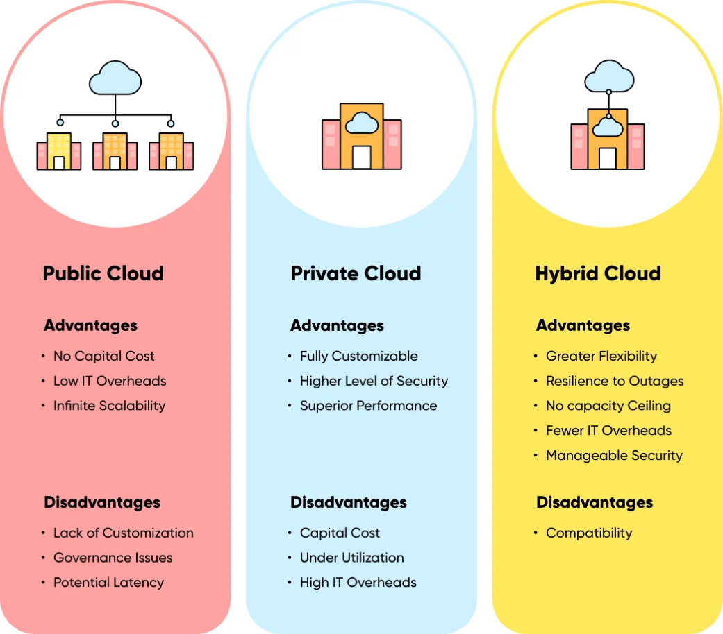
Cloud computing is the adoption of IT based services through the internet. This is usually produced on a pay as you go basis and allows for a consumer to pay for what they use. Cloud computing is produced instead of owning physical on-site servers and data storage. The significance of cloud computing in the mind of scalability is its ability to be agile, flexible and cost effective (Amazon,2024). Cloud computing services are easily scalable as the number of resources used can be increased and decreased easily and quickly (databases, users). The main method of deployment includes Private cloud, public cloud and Hybrid cloud. These three frameworks are used to set up appropriate cloud servers for the consumer.
Figure 2 different cloud deployment methods (Net Solutions, 2023)

Please see appendix 3 for a breakdown of the three deployment models.
Much like the three deployment models there are also three main cloud frameworks for the construction and deployment of cloud resources. They include Infrastructure as a service (IaaS), Platform as a service (PaaS) and Software as a service (SaaS) (IBM,2024).
see appendix 4 for a breakdown of the three computing models.
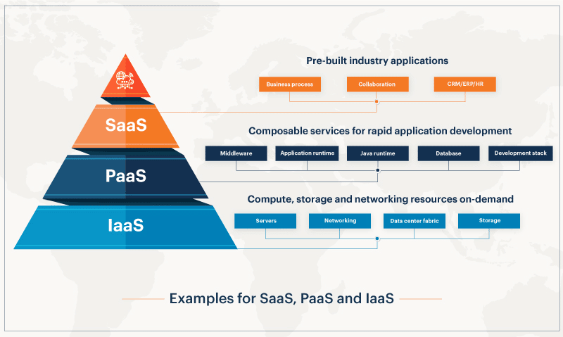
Figure 3 Cloud SaaS, PaaS and IaaS diagram (Kinsta®, 2022)

From the research conducted the most appropriate resource for providing both high security and low security protection is the implementation of a hybrid cloud model. Hybrid clouds are a combination of both private and public cloud models, providing the flexibility and management of both (Harness.io, 2024).
Hybrid clouds can be used to enable resource scalability as well as provide regulatory compliance and protection of sensitive data. By utilising both private and public cloud models, hybrid cloud services can provide high security data protection by utilising a private cloud as well as deploying scalability and accessibility with a public cloud (Google Cloud, 2024).
Similar to this, the company should look to use the different services provided by cloud computing, specifically Infrastructure as a Service (IaaS) and platform as a service (PaaS). The significance of using IaaS is the security features that it deploys. IaaS is a leased cloud environment and is easily scalable. The significance of this is that the security features of the environment are monitored and enforced by the provider and thus data is stored safely. Similar to this, the use of PaaS is ideal for the storage of data. The tools are deployed as a service and provide pre-built methods of managing and analysing databases (Slingerland, 2023). As a combination the use of IaaS and PaaS could suit Venuestream given the security needs as well as the scalability preferences.

Literature review:
The main two databases used are IEEE Xplore (IEEE XPLORE) and Google (Google, 2024). Both provide filtering tools and allow me to access data that was relevant and up to date. For both filters were provided to keep the information within the last 10 years. This is due to the speed of development that cloud computing has undergone, to which the service is constantly changing and in regard to security specifically, the vulnerabilities change consistently.
Keyword searches have been the main basis for finding sources. I have used keyword and string searches associated with the created research questions to return resources based on the given themes. Through this process, I have also used different synonyms and alternative wording to maximise my coverage. An example of this includes my search for different cloud security frameworks. I noticed that the words “framework” and “model” are interchanged depending on the origin of the source, but the content was describing the same issues.
Table 1Table showing basic search terms

From these search terms qualitative data was gathered and detailed searches were conducted leaning on topics including NAT, Ip auto configuration and various cloud models. These were performed in a similar way to the search terms shown in table 1.
From the references a system was created to determine whether the reference was strong enough to represent the point made in text. The system is as follows and worked on a numeral system (3 exceptional detail, 2 provides adequate detail, 1 lacks detail). From this, the sources that produced a score 2 or higher was deemed suitable for using, when discussing concepts these sources were only used if ‘yes’ was selected for correlation as this would show that the information derived was weighted.

Table 2 Referencing scoring system including examples

Part 2 IPv6 Addressing of the Computer Network:
Table 3 IPv6 subnet address
Subnet Description | Subnet Id | IPv6 Network Prefix /Prefix Length
HQ LAN1 | 085E | 2001:db8:acad:85e ::/64
HQ LAN 2 | 085F | 2001:db8:acad:85f::/64
Branch IoT LAN | 0860 | 2001:db8:acad:860::/64
Branch CCTV LAN | 0861 | 2001:db8:acad:861::/64

The subnet ID was calculated the following way:
2142 = 100001011110 (binary) = 085E (hexadecimal)
085E = (2142)/16 = 133 remainder 14 (E)
(133)/16 = 8 remainder 5
(8)/16 = 8 remainder 8
=(85E) ₁₆
85E = 8*16² + 5*16¹+14*16º=2142₁₀
To work out the IPv6 network prefix I utilised the EUI-64 configuration and then implemented my generated hexadecimal as the subnet-ID, this was then increased by 1 for each address formed.
An example is shown below:
Global Routing Prefix (48 Bits)
Subnet ID (16 Bits)
Interface ID (64 Bits)
A /48 routing prefix + 16-bit subnet ID = /64
For example, HQ LAN1:
2001:DB8:ACAD::/48 + 085E = 2001:DB8:ACAD:085E::/64
Compressed format (‘0s’ omitted) = 2001:DB8:ACAD:85E::/64

Table 4 IPv6 interface address table
Network Device | Interface | MAC Address | Global IPv6 Address/Prefix Length | Link Local Address
HQ  BR1 | G0/0 | 0003.E498.9E01 | 2001:db8:acad:85e:203:e4ff:fe98:9e01/64 | fe80::203:e4ff:fe98:9e01
 | G0/1 | 0003.E498.9E02 | 2001:db8:acad:860:203:e4ff:fe98:9e02/64 | fe80::203:e4ff:fe98:9e02
Branch | G0/0 | 0001.632C.B901 | 2001:db8:acad:860:201:63ff:ef2c:b901/64 | fe80::201:63ff:fe2c:b901
BR2 | G0/1 | 0001.632C.B902 | 2001:db8:acad:861:201:63ff:ef2c:b902/64 | fe80::201:63ff:fe2c:b902

To work out the global IPv6 address as well as the link local address I completed the following steps:
Mac address = 0003.E498.9E01
Split the address to convert it to 64 bits using the EUI-64 (Extended unique identifier).
Example:
0003:E4 FF:FE 98:9E01
Convert the 7th bit from the left
Convert first 2 hexadecimal numbers to binary:
00000000 – if ‘0’ then convert to a 1 and vice versa. In this case I have done the following:
00000010 therefore the address is as follows:
0203:E4FF:FE98:9E01/64
Compress that to:
203:E4FF:FE98:9E01/64
And then add the EUI-64 unique address to the 64 bits as well as the subnet ID formulated earlier to make 128 Bits. Thus, the address is as follows:
2001:db8:acad:862:203:e4ff:fe98:9e01/64

Table 5 IPv6 interface address table
End Device | MAC Address | IPv6 Device Address /Prefix Length | Link Local Address
HQ1 | 00D0.BCDD.315B | 2001:db8:acad:85e:2d0:bcff:fedd:315b/64 | fe80::2d0:bcff:fedd:315b
HQ2 | 0060.473E.585C | 2001:db8:acad:85f:260:47ff:fe3e:585c/64 | fe80::260:47ff:fe3e:585c
HQserver | 0060.47C8.7111 | 2001:db8:acad:85f:260:47ff:f3c8:7111/64 | fe80::260:47ff:fec8:7111
BR IoT Device | 00D0.58A6.7034 | 2001:db8:acad:860:2d0:58ff:fea6:7034/64 | fe80::2d0:58ff:fea6:7034
BR CCTV Camera | 0060.5CDD.DE36 | 2001:db8:acad:861:260:5cff:fedd:de36/64 | fe80::260:5cff:fedd:de36
BRServer | 0030.A328:56A0 | 2001:db8:acad:861:230:a3ff:fe28:56a0/64 | fe80::230:a3ff:fe28:56a0

Note: The devices that have the same Link Local address share a network and as a result they share LLA as well.
See appendix 5 for image.

References:
A10 Networks. (2024.). What is IPv6 Migration, Why is it Necessary? | Glossary. [online] Available at: https://www.a10networks.com/glossary/what-is-ipv6-migration-and-why-is-it-necessary/ Accessed [October 10th 2024].
Amazon (2024.). What is Cloud Computing? - Amazon Web Services. [online] Amazon Web Services, Inc. Available at: https://aws.amazon.com/what-is-cloud-computing/ Accessed: [October 10th, 2024].
Amazon Web Services (2024). What is IPSec? - IPSec Protocol Explained - AWS. [online] Amazon Web Services, Inc. Available at: https://aws.amazon.com/what-is/ipsec/ Accessed [October 10th, 2024].
Amazon Web Services, Inc. (2019). Types of cloud computing. [online] Available at: https://aws.amazon.com/types-of-cloud-computing/?WICC-N=tile&tile=types_of_cloud. [November 15th 2024]
Amazon Web Services, Inc. (2024). IPv4 vs IPv6 - Difference Between Internet Protocol Versions - AWS. [online] Available at: https://aws.amazon.com/compare/the-difference-between-ipv4-and-ipv6/[October 10th, 2024]..
Amazon Web Services, Inc. (n.d.). IPv4 vs IPv6 - Difference Between Internet Protocol Versions - AWS. [online] Available at: https://aws.amazon.com/compare/the-difference-between-ipv4-and-ipv6/ [October 10th, 2024].
AWS (2024). What Is Virtualization? - Cloud Computing Virtualization - AWS. [online] Amazon Web Services, Inc. Available at: https://aws.amazon.com/what-is/virtualization/. [November 15th 2024]
azure.microsoft.com. (2024.). What is Virtualization - Definition | Microsoft Azure. [online] Available at: https://azure.microsoft.com/en-in/resources/cloud-computing-dictionary/what-is-virtualization [October 10th, 2024]..
azure.microsoft.com. (n2024.). Public Cloud vs Private Cloud vs Hybrid Cloud | Microsoft Azure. [online] Available at: https://azure.microsoft.com/en-au/resources/cloud-computing-dictionary/what-are-private-public-hybrid-clouds. [November 15th 2024]
B. Garn, D. E. Simos, F. Duan, Y. Lei, J. Bozic and F. Wotawa, "Weighted Combinatorial Sequence Testing for the TLS Protocol," 2019 IEEE International Conference on Software Testing, Verification and Validation Workshops (ICSTW), Xi'an, China, 2019, pp. 46-51, doi: 10.1109/ICSTW.2019.00031. keywords: {Testing;Protocols;Security;Software;Servers;Computer bugs;Databases;combinatorial testing;security testing;sequence testing;tls protocol},
blog.servermania.com. (n.d.). IPv4 vs IPv6 – What’s the Difference and Which Is Better? [online] Available at: https://blog.servermania.com/ipv4-vs-ipv6. [October 10th, 2024].
Cloudflare (2022). What is IPsec? | How IPsec VPNs work | Cloudflare UK. Cloudflare. [online] Available at: https://www.cloudflare.com/en-gb/learning/network-layer/what-is-ipsec/.[October 10th, 2024].
D. Zagar and K. Grgic, "IPv6 Security Threats and Possible Solutions," 2006 World Automation Congress, Budapest, Hungary, 2006, pp. 1-7, doi: 10.1109/WAC.2006.375753. keywords: {Information security;Protocols;Data security;Reconnaissance;Routing;Quality of service;Intrusion detection;Probes;Automation;Testing;IPv6;Network security;Firewall;Intrusion detection}, [November 15th 2024]
Giac.org. (2022). Available at: https://www.giac.org/paper/gsec/2158/security-features-ipv6/103684. [October 10th, 2024].
Google Cloud (2023). What Is PaaS? [online] Google Cloud. Available at: https://cloud.google.com/learn/what-is-paas. [November 15th 2024]
Google Cloud (2024). What are the different types of cloud computing? [online] Google Cloud. Available at: https://cloud.google.com/discover/types-of-cloud-computing. [October 10th, 2024].
Google Cloud (2024). What is Hybrid Cloud? [online] Google Cloud. Available at: https://cloud.google.com/learn/what-is-hybrid-cloud. [November 15th 2024]
Google Cloud (2024). What is IaaS (Infrastructure as a Service)? [online] Google Cloud. Available at: https://cloud.google.com/learn/what-is-iaas. [October 10th, 2024].
H. Rafiee and C. Meinel, "SSAS: A simple secure addressing scheme for IPv6 autoconfiguration," 2013 Eleventh Annual Conference on Privacy, Security and Trust, Tarragona, Spain, 2013, pp. 275-282, doi: 10.1109/PST.2013.6596063. keywords: {Public key;IP networks;Privacy;Routing protocols;Databases;Stateless Autoconfiguration;NDP;public/private key;IPv6;IPv6 addressing;Randomized Interface ID},[October 10th, 2024].
Harness.io. (2024). Choosing the Right Cloud Deployment Model. [online] Available at: https://www.harness.io/blog/choosing-the-right-cloud-deployment-model [Accessed 28 Oct. 2024].
Ieee.org. (2024). IEEE Xplore Search Results. [online] Available at: https://ieeexplore.ieee.org/search/searchresult.jsp?newsearch=true&queryText=hybrid%20cloud%20services [Accessed 29 Oct. 2024].
Kapoor, A. (2023). Understand the Difference Between IPv4 and IPv6 | Simplilearn. [online] Simplilearn.com. Available at: https://www.simplilearn.com/tutorials/cyber-security-tutorial/difference-between-ipv4-and-ipv6. [October 10th, 2024].
Kinsta®. (2022). IaaS vs PaaS: What’s the Difference? [online] Available at: https://kinsta.com/blog/iaas-vs-paas/.[Accessed 29 Oct. 2024].
Kuerbis, B. and Mueller, M. (2020). The hidden standards war: economic factors affecting IPv6 deployment. Digital Policy, Regulation and Governance, 22(4), pp.333–361. doi:https://doi.org/10.1108/dprg-10-2019-0085. [Accessed 29 Oct. 2024].
KUERBIS, B. and MUELLER, M., 2020. The hidden standards war: economic factors affecting IPv6 deployment. Digital Policy, Regulation and Governance, 22(4), pp. 333-361. [October 10th, 2024].
Net Solutions (2023). What is Cloud Computing? Net Solutions’ Knowledge Hub. [online] Net Solutions. Available at: https://www.netsolutions.com/hub/cloud-computing/. [October 10th, 2024].
Madsen, T. (2023). IPv6 Security – Part 2. [online] Cybersecurity Magazine. Available at: https://cybersecurity-magazine.com/ipv6-security-part-2/.[Accessed 29 Oct. 2024].
Microsoft (2023). What is SaaS? Software as a Service | Microsoft Azure. [online] azure.microsoft.com. Available at: https://azure.microsoft.com/en-us/resources/cloud-computing-dictionary/what-is-saas. [Accessed 29 Oct. 2024].
Net Solutions (2023). What is Cloud Computing? Net Solutions’ Knowledge Hub. [online] Net Solutions. Available at: https://www.netsolutions.com/hub/cloud-computing/.[Accessed 29 Oct. 2024].
NetworkAcademy.io. (n.d.). IPv4 vs IPv6 - Understanding the differences. [online] Available at: https://www.networkacademy.io/ccna/ipv6/ipv4-vs-ipv6. [November 15th 2024]
Nizar, A. and Ali, A. (2012). Comparison study between IPV4 & IPV6. [online] Available at: https://citeseerx.ist.psu.edu/document?repid=rep1&type=pdf&doi=39a26364026e2fbee41a2bfe0329e9f4d6b7a6d3. [Accessed 29 Oct. 2024].
Nizar, A. and Ali, A. (2012). Comparison study between IPV4 & IPV6. [online] Available at: https://citeseerx.ist.psu.edu/document?repid=rep1&type=pdf&doi=39a26364026e2fbee41a2bfe0329e9f4d6b7a6d3. [Accessed 29 Oct. 2024].
Ordabayeva, G.K., Othman, M., Kirgizbayeva, B., Iztaev, Zh.D. and Bayegizova, A. (2020). A Systematic Review of Transition from IPV4 To IPV6. Proceedings of the 6th International Conference on Engineering & MIS 2020. doi:https://doi.org/10.1145/3410352.3410735. [November 15th 2024]
PICKARD, J., SOUTHWORTH, J. and DRUMMOND, D., 2017. THE IPV6 INTERNET: AN ASSESSMENT OF ADOPTION AND QUALITY OF SERVICES. Journal of International Technology and Information Management, 26(2), pp. 48-64. [November 15th 2024]
R. Ghafouri, A. Ashrafi and B. V. Vahdat, "Security consideration of migration to IPv6 with NAT (Network Address Translation) methods," 2015 23rd Iranian Conference on Electrical Engineering, Tehran, Iran, 2015, pp. 746-749, doi: 10.1109/IranianCEE.2015.7146312. keywords: {Decision support systems;Electrical engineering;Conferences;IPv6;Migration;NAT;Vulnerability;security;Attack;Threat}, [November 15th 2024]
Samantha (2020). 6 Advantages Of IPv6 To IPv4 Address - Monsterhost. [online] monsterhost.com. Available at: https://monsterhost.com/ipv6-to-ipv4/. [November 15th 2024]
Sharma, V. (2010). IPv6 and IPv4 Security challenge Analysis and Best-Practice Scenario. Int. J. of Advanced of Networking and Applications, [online] 258, pp.258–269. Available at: https://citeseerx.ist.psu.edu/document?repid=rep1&type=pdf&doi=439cac5722e67f9e6cc9b7a087559cab625fcf8d. [Accessed 29 Oct. 2024].
SiteGround Web Hosting (2024). SiteGround. [online] SiteGround. Available at: https://www.siteground.co.uk/kb/ipv4-vs-ipv6/. [November 15th 2024]
Slingerland, C. (2023). The 4 Types Of Cloud Computing: Choosing The Best Model. [online] CloudZero. Available at: https://www.cloudzero.com/blog/types-of-cloud-computing/.[Accessed 29 Oct. 2024].
VMware (2024). What is Software-Defined Networking (SDN)? | VMware Glossary. [online] www.vmware.com. Available at: https://www.vmware.com/topics/software-defined-networking. [November 15th 2024]
www.juniper.net. (2024). What is the difference between IPv4 and IPv6? | Juniper Networks UK&I. [online] Available at: https://www.juniper.net/gb/en/research-topics/what-is-ipv4-vs-ipv6.html. Accessed [November 15th 2024]
www.varonis.com. (2024.). IPv6 Security Guide: Do you Have a Blindspot? [online] Available at: https://www.varonis.com/blog/ipv6-security. [Accessed 29 Oct. 2024].

Appendix:
Appendix 1 ipsec.
IPsec can provide some or all the following protection when using IPv6:
· Provide router security when sending and receiving data across public channels
· The encryption of application data
· Authentication of data quickly if the data is received from a known sender
·The ability to protect network data by establishing encrypted circuits called IPsec tunnels, these encrypt all data sent between the two endpoints (AWS,2024).
· IPSec protocols assign a sequential number to every data packet and through this performs checks to detect and determine signs of duplicate packets – this specific feature prevents replay attacks/attacks focused on data intercepts.
·IPSec uses both asymmetric and symmetric encryption to provide security and speed during the transfer of data. In asymmetric encryption, the encryption key is public however the decryption key is private. Symmetric encryption uses the same key for both encryption and decryption (Cloudflare, 2022).

Appendix 2 NAT.
Although there are ways of dealing with the lack of address space in IPv4, including the use of network address translation (NAT). The use of NAT Is not always ideal given that it sometimes struggles with modern internet applications. As well as this, NAT is traditionally used for business-to-business interactions with direct network connections, this means that a complicated address translator is needed to make the connection work properly. As a result of this, NAT is not as efficient as IPv6 and the larger address space, and as a result producing poor scalability, and producing a vulnerability given its single point of failure.
Leading on from this, by expanding the branches and keeping the cost of staffing lower as well as increasing the efficiency of scaling the branches, IPv6 makes NAT unnecessary. This improves the overall connectivity as well as the reliability and implementing flexibility into the process. The addresses produced by IPv6 are larger and complicated in nature and as a result fewer people are needed to translate them due to the built-in functions (Nizar and Ali, 2012).

Appendix 3 Virtualization.
Virtualization:
Another concept to consider when increasing scalability includes the practice of virtualization. Virtualization is the process of creating multiple simulated computing environments rather than having a physical one. Virtualization can include the creation of computing software, hardware and databases/storage (azure.microsoft.com, 2024.). The significance of virtualization for scalability is that Venuestream can produce multiple virtual machines off of a single computer or server, each virtual system having the ability to run their own operating systems and working independently. This aids in scalability as it allows for a consumer to produce less energy, produce more resources from fewer servers whilst saving money on infrastructure and maintenance costs (AWS, 2024).
Software defined network:
Software defined networking (SDN) is a method of developing a network using software-based controllers of application programming interfaces (APIs). These methods are used to communicate with the infrastructure as well as the network traffic. This method is used to bypass traditional network methods that use switches and routers, this is done by creating a virtual network.
The significance of this in regard to Venuestream and their scalability concerns involves the fact that instead of needing the ability to manually control hardware devices, the consumer can control the flow of network traffic by using an open standard software-based controller. Regarding expansion, it also allows for Venuestream to select the amount of equipment used, SDN allows for a single protocol to communicate with any given hardware device through a single control central (VMware, 2024).
Other benefits of a software defined network:
- Using SDN the administrator can change the network in real time, virtual resources can be allocated and deployed easily and quickly to alter the infrastructure, as a result the administrator can allocate and optimise the network to work around and through applications that need priority, this is done by altering the data flow (VMware, 2024).
- Robust security is another benefit of SDN which is another benefit to Venustream. The use of SDN allows for the admin to gain visibility to the entire network and thus providing a holistic view of security threats. This is a clear advantage over standard networks as SDN allows for the creation of different zones that will have different configurations to deal with different levels of security. By the same principle, administrators can quarantine and section off areas that have been breached, this can be completed quickly (VMware, 2024).

Appendix 4 Cloud services.
The 3 different Cloud services:
- Hybrid cloud - Hybrid cloud is a service that combines both public cloud and private cloud. Hybrid cloud allows for data and applications to move between the two environments. Hybrid cloud is a used option by businesses as it addresses data sovereignty requirements and regulations as well as utilising existing on-site investment as well as low latency issues (Microsoft, 2024).
- Public cloud - public clouds are the most popular cloud service, the cloud service is owned by a third party who provides aspects including storage and storage. With a public cloud all software, hardware and infrastructure are owned by the third party providing the service. As a result of this systems can be shared with other consumers known as ‘cloud tenants’ (Microsoft, 2024).
- Private cloud - Private cloud involves the internal development and deployment of cloud services exclusive to the consumer. This is usually located on premises datacentre or through a third-party agency. With Private cloud, the infrastructure and software are exclusively maintained by the organisation owning the service, thus allowing for increased control, organisation and security (Microsoft, 2024).
Appendix 5 Cloud models.
The different Cloud models:
- Infrastructure as a service (IaaS) - IaaS is a cloud model that provides on-demand access to computer resources including servers, storage, virtualization and networking. This allows for a consumer to alleviate the need for physical on premises resources that would need to be consistently managed and physically scaled. IaaS reduces this and serves this on a pay as you go basis (Google cloud, 2024).
- Platform as a service (PaaS) - PaaS is a cloud model that is provided by a third party, the third party provides a complete cloud platform that includes everything that a consumer needs to develop, run and manage a cloud application. This includes servers, operating systems, databases and middleware. PaaS increases scalability and security as this is the responsibility of the provider of the PaaS (Google cloud, 2023).
- Software as a Service (SaaS) - SaaS is the process in which a consumer purchases a cloud-based software on a pay as you go basis from a cloud service provider. The consumer rents the use of an app or platform, and then the consumer applies the software to their business. The significance of SaaS is found within scalability as the provider of the software is responsible for the storage of data, the management of the software as well as the infrastructure and middleware. Leading on from this, the provider will also maintain the software, hardware and ensure security of the product (Microsoft, 2023).
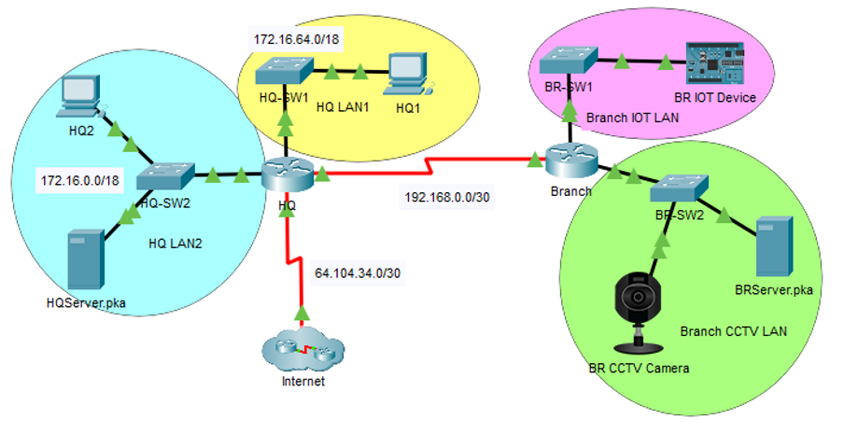
Appendix 5 Venuestream network image.
Figure 4 Venuestream network
Venuestream Network image

